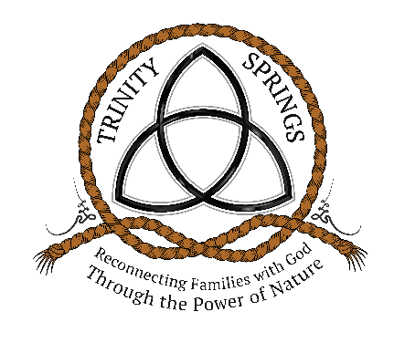
Retreat Family Guidelines
The information below is provided to ensure the families
attending a retreat at Trinity Springs have an amazing experience.

~ We focus on families that have lost a child; families that have a child living
through a life-threatening condition; and military families
dealing with loss or trauma.

~ We develop partnerships with Children and Veteran Hospitals. Knowing Trinity Springs and the needs of the families receiving treatment,
our partner hospitals nominate families for retreat.
Trinity Springs does not select the families, our partner hospitals do.
Families are then contacted by Trinity Springs and scheduled for retreat.

~ Our program is focused on the family as a whole. We know sometimes it’s hard to take time off work, however, priority will be given to
families who can attend together.

~ Each retreat is limited to the immediate family, the parents and children living at home. If you are a single parent, you may bring another adult who has walked through the journey with the family.

~ Retreats are scheduled for Thursday through Sunday morning. We encourage families to travel on Wednesday and to arrive Wednesday evening. If a family is unable to check-in to Trinity Springs on their designated start date,
we ask our guests to inform us as soon as possible on their arrival time.

~ If a guest needs or wants to check-out early, we ask that they inform us
as soon as possible prior to or during their stay.

~ No alcohol or smoking is allowed during the retreat.
~ We welcome all families regardless of race, religious affiliation,
financial status or demographic location.

~ Thanks to our generous donors, all retreats are free to all of our families excluding travel costs. Families are responsible for the cost of traveling
to and from their home to Trinity Springs.

~ All meals are provided during your stay at Trinity Springs.
If you have dietary needs, please inform us of those needs and we will incorporate them into our meal plan. The kitchen will always be available for our guests and is stocked with various snacks and drinks; but no cooking is allowed. Guests are more than welcome to go into town and
dine at local restaurants as well.

~ During retreat, guests can participate in as much or as little as they like. We have a schedule of various activities available for our guests to partake in, but nothing is required while staying at Trinity Springs. During the planning process, we do our best to customize each families’ retreat.

~ Retreat activities include: Fishing, horseback riding, participating in daily ranch chores, walking the trails, stargazing around the fire pit, relaxing in the courtyard, creating memorial crafts, tending the garden, canoeing, picking vegetables for the evening meal, sessions with our counselor, camping, site seeing the Ozarks natural beauty, Wildlife viewing and photography, s’mores around the fire pit, and many other relaxing and therapeutic activities which are customized for each retreat.

~ No pets are allowed.

~ No firearms/weapons of any kind are allowed during the retreat.

~ Parents are responsible for the actions of all family members and must take all children under 18 years old if leaving the ranch at any time.

~ Retreat families are responsible to bring and administer their own medications and treatments. If medical care is needed; Trinity Springs will rely on area EMS out of Willow Springs, Missouri (10 miles door to door).

Please don’t hesitate to contact us at trinityspringsnonprofit@gmail.com or
(417)469–0810 if you have any questions.

